ISSS608 Visual Analytics and Applications
Timed Individual Assessment

DataVis Makeover is the process of redesigning existing data visualisation or dashboards to improve their clarity, effectiveness, and storytelling capacity. It focuses on applying best practices to make data easier to understand.

The Task
- Evaluate the data visualisation provided by identifying its strengths and weaknesses.
- Sketch a redesigned visualisation that improves the clarity, effectiveness, and storytelling of the original.
- Create the redesigned visualisation (DataVis Makeover) using Tableau Desktop.
- Describe the labour force participation trends and patterns reveal by the DataVis Makeover.

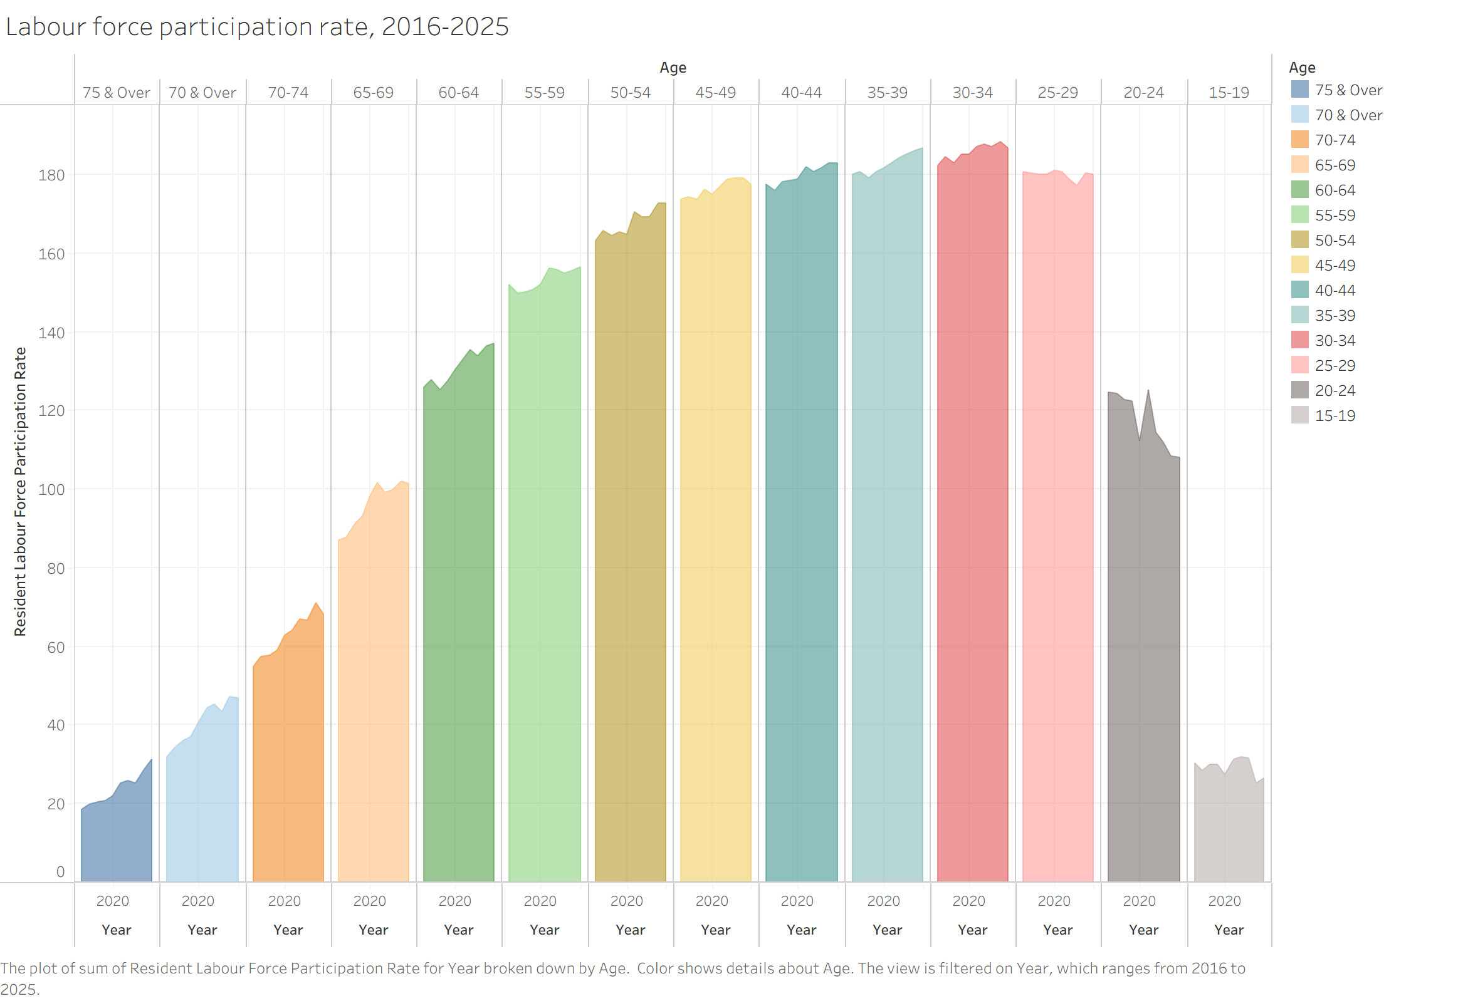

Submission Instructions
This is a timed individual assessment. You are required to complete the DataVis Makeover individually within 1 hour and 30 minutes during the class session.

- Write-up
You are required to submit a write-up in Microsoft Word format via eLearn. The write-up should include, but is not limited to, the following:
- At least three strengths of the original data visualisation.
- At least two weaknesses related to clarity and two related to aesthetic of the original data visualisation.
- A sketch of the redesigned visualisation, together with a brief explanation of how the redesign addresses the weaknesses identified in the original visualisation.
- At least five labour force participation trends and patterns revealed by the DataVis Makeover.

- Tableau Visualisation
Publish your DataVis Makeover on Tableau Public and submit the link via eLearn.

Assessment Rubic
Criteria | Excellent | Good | Satisfactory | Needs Improvement | Weights
Critique of Original Data Visualisation | Provides clear, insightful, and well-structured critique. Strengths and weaknesses are accurately identified and well justified using data visualisation principles. | Provides a logical critique with appropriate identification of strengths and weaknesses, with some supporting explanation. | Identifies some strengths and weaknesses but explanations are limited or partially unclear. | Limited or unclear critique. Strengths and weaknesses are poorly identified or unsupported. | 20%
Redesign Proposal (Sketch & Explanation) | Redesign sketch is clear and well thought out. Explanation clearly shows how the new design addresses the weaknesses and improves clarity and storytelling. | Redesign is reasonable and addresses most weaknesses. Explanation is generally clear. | Redesign addresses some weaknesses but explanation lacks clarity or completeness. | Redesign is unclear or does not meaningfully address the weaknesses identified. | 20%
Implementation Using Tableau Desktop | Tableau visualisation is well designed, clear, and visually effective. Appropriate chart types, layout, labels, and formatting are used. | Tableau visualisation is generally clear with appropriate chart type and layout, with minor issues. | Tableau visualisation is functional but contains several clarity or formatting issues. | Tableau visualisation is incomplete, difficult to interpret, or poorly implemented. | 25%
Visual Storytelling and Insight Communication | Provides clear and insightful interpretation of trends and patterns revealed by the DataVis Makeover. Insights are well articulated and supported by the visualisation. | Describes key trends and patterns with reasonable clarity, though explanation may lack depth. | Identifies some trends or patterns but explanation is limited or partially unclear. | Little or no meaningful interpretation of the trends or patterns shown in the visualisation. | 20%
Bonus: Creativity & Storytelling | Demonstrates exceptional creativity, strong visual hierarchy, and compelling storytelling. | Shows good creativity and visual improvement over the original design. | Shows limited creativity but improves some aspects of the original visualisation. | Little or no improvement in creativity or storytelling. | 15%

ISSS608 Visual Analytics and Applications
Timed Individual Assessment
Nguyen Trong Nhan

1. Strengths of the original visualisation
1.1 Appropriate use of small multiples to facilitate age-group comparison. The original visualisation uses a small-multiples layout, placing each age group in its own panel with a shared Y-axis. This design follows Tufte’s (2001) principle that small multiples are “the best design solution for a wide range of problems in data presentation” because they allow the reader to compare patterns across groups while holding the visual encoding constant. The reader can scan across panels to compare the shape and level of LFPR curves for different age groups.
1.2 Time-series encoding preserves temporal trends within each age group. Within each panel, LFPR is plotted over time (2016-2025) as an area chart, which makes it possible to see the trajectory for each age group whether participation is rising, falling, or stable. The use of a continuous time axis, rather than discrete bars, is appropriate for showing gradual demographic shifts (Few, 2012).
1.3 Ordering of age groups from oldest to youngest reveals the age gradient. The panels are arranged left-to-right from “75 & Over” to “15-19”, and the resulting visual silhouette, low on the far left, rising to a peak around 30-44, then declining on the right, produces an intuitive “mountain” shape that communicates the inverted-U age profile of labour force participation at a glance.
1.4 Distinct color per age group aids panel identification. Each age group is assigned a unique color, which helps the reader identify and locate specific panels when scanning the chart. This categorical use of color is consistent with best practices for nominal encoding (Ware, 2021), where the goal is to make each category visually distinguishable rather than to imply a quantitative ordering.
1.5 Consistent Y-axis scale across all panels enables cross-panel height comparison. All panels share the same Y-axis (0 to around 190), which means the visual height of the area in one panel is directly comparable to the height in another. This is a critical design choice for small multiples; without a common scale, comparisons across panels would be misleading (Cleveland & McGill, 1984).
2. Weaknesses of the original visualisation
a. Clarity weaknesses
a.1 Male and female LFPR are summed instead of separated, producing misleading values above 100%. This is the most critical flaw. The Y-axis reaches approximately 190, and the Tableau caption confirms the chart plots “sum of Resident Labour Force Participation Rate.” Labour force participation rate is a percentage (0-100%) for a given demographic. Summing male and female rates produces a meaningless composite (e.g., for the 25-29 age group in 2020: male 89.7% + female 91.1% = 180.8%). This violates the fundamental requirement that visualised metrics must be semantically valid (Few, 2012). A reader unfamiliar with the data would interpret “180” as a participation rate exceeding 100%, which is impossible and deeply misleading.
a.2 The gender dimension is completely hidden, obscuring the most important analytical story. The dataset contains separate male and female LFPR values, yet the chart aggregates them into a single area. This hides the dramatic gender convergence story: in the 30–34 age group, the male–female gap narrowed from 38.7 percentage points in 1991 to just 5.6 points in 2025. In the 25-29 group, female LFPR (93.0%) now exceeds male LFPR (87.0%) by 6 points. These are among the most significant labour market trends in Singapore, yet they are entirely invisible in the original chart. As Knaflic (2015) emphasises, effective visualisation should surface the story in the data, not suppress it.
a.3 The time range is limited to 2016-2025, truncating the long-term structural trend. The dataset spans 1991-2025, yet the original chart filters to only 2016-2025. This truncation hides the most dramatic shifts: for instance, female LFPR in the 35–39 age group rose from 55.3% in 1991 to 90.3% in 2025, a 35-point increase. Showing only the last decade, where the rate moved from 82.3% to 90.3%, makes this transformation appear as a modest incremental rise rather than the structural revolution it actually represents.
b. Aesthetic weaknesses
b.1 Repetitive and uninformative X-axis labels. Every panel displays “2020” and “Year” as its X-axis label, repeated 14 times across the chart. This wastes significant horizontal space and adds visual clutter without providing useful information. In a well-designed small-multiples layout, axis labels should appear once (on the first or last panel, or as a shared label) rather than being duplicated, to maximize the data-ink ratio (Tufte, 2001).
b.2 Excessive use of 14 distinct colors creates visual noise rather than analytical insight. Each of the 14 age groups is assigned a unique color, resulting in a rainbow palette that is difficult to distinguish and remember. Research on pre-attentive processing suggests that humans can reliably distinguish approximately 6-8 color categories (Ware, 2021). With 14 colors, the palette becomes decorative rather than functional, the reader cannot identify, for example, which pastel shade corresponds to “45-49” without consulting the legend. Since the age groups are already spatially separated into panels, the per-panel color adds no analytical information and merely increases the cognitive load.
b.3 Area chart fill obscures precise values and creates a false impression of volume. The use of filled area charts implies that the area under the curve is meaningful, as in a stacked area chart or a chart showing quantities that accumulate. However, LFPR is a rate (a proportion), not a volume or count. A line chart would communicate the same trend information more cleanly, without the visual weight of the filled area creating a misleading “mass” impression (Few, 2012). The fill also makes it harder to read precise values from the chart, as the eye is drawn to the colored region rather than the edge that encodes the data.
3. Redesign Sketch and Explanation
a. Brainstormed redesign sketch (draft):
Note: I did not have a red pen to demonstrate female, so I used a black pen for female (and blue for male) in this draft sketch.
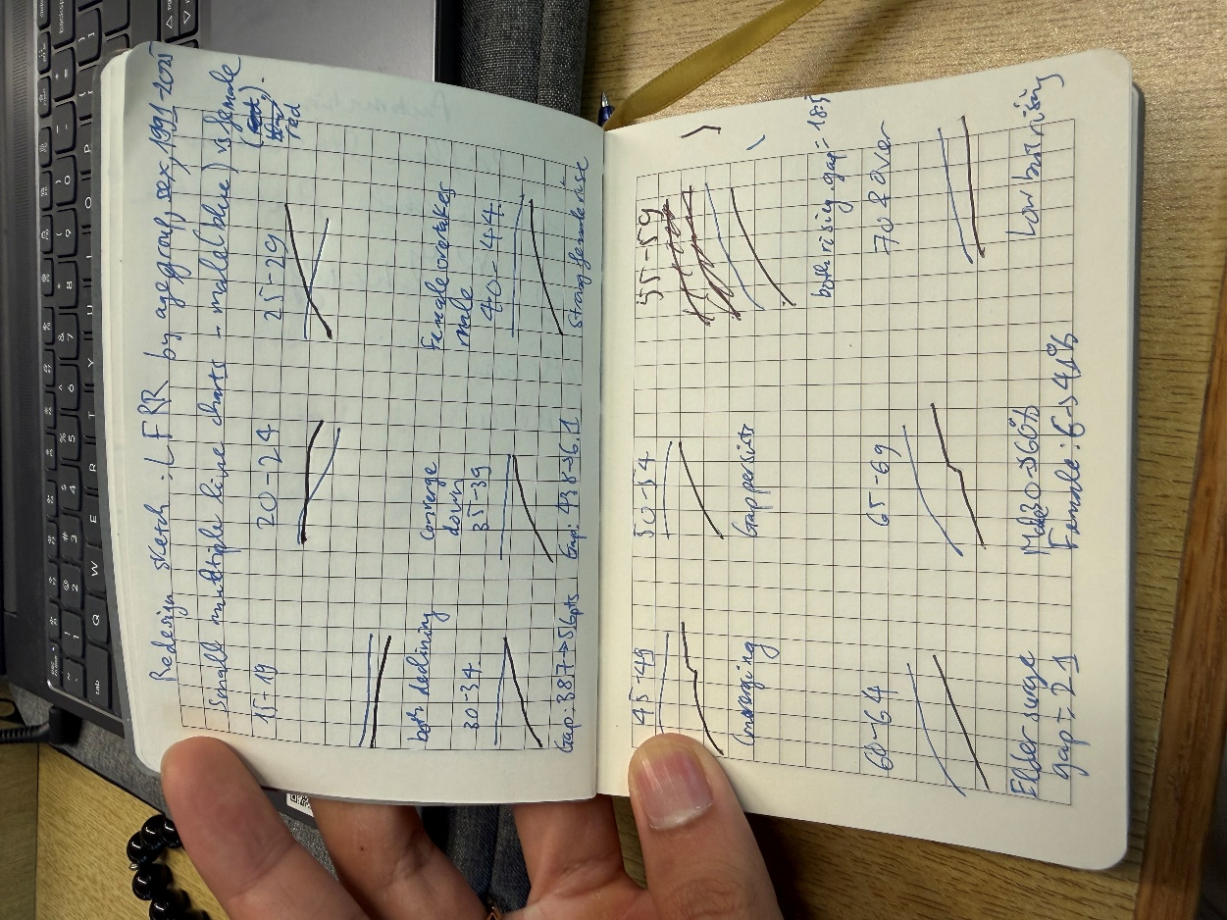
Figure 1. Brainstormed Redesign Sketch.

b. Redesign description
The redesign uses a small-multiples line chart with one panel per age group, where each panel displays two lines: one for male, one for female plotted over the full time range 1991-2025. The specific design elements are:
X-axis: Years 1991-2025, utilising the full dataset instead of truncating to 2016.
Y-axis: LFPR from 0% to 100%, since each line represents a single sex within a single age group, semantically valid rate.
Two lines per panel: Male (blue) and Female (red), using only two colors consistently across all panels. The gap between the two lines directly encodes the gender participation gap, making convergence or divergence immediately visible.
Panel arrangement: Age groups arranged in a grid (e.g., 3 rows × 4 columns), ordered from youngest to oldest, reading left-to-right then top-to-bottom in the natural reading direction.
Interactive tooltips: Hovering on any point shows the exact LFPR, year, sex, and the male-female gap for that age group and year.

c. How the redesign addresses each weakness
Weakness 2a.1 (summed rates above 100%) => Each line represents a single sex within a single age group, so all values fall within the valid 0–100% range. The metric is now semantically correct.
Weakness 2a.2 (gender dimension hidden) => Male and female are shown as separate lines, making the gender gap and convergence trend the central visual feature of every panel.
Weakness 2a.3 (truncated time range) => The full 1991-2025 range is used to reveal the long-term structural transformation of female labour force participation.
Weakness 2b.1 (repetitive X-axis labels) => Axis labels are shared across the grid rather than repeated per panel, reducing clutter and maximizing space for data.
Weakness 2b.2 (14 colors) => Only two colors are used (blue for male, red for female), applied consistently across all panels. Color now encodes the analytically important variable (sex) rather than a redundant one (age group, already encoded by panel position).
Weakness 2b.3 (area chart fill) => Line charts replace area charts, removing the false volume impression and making precise trend reading easier. The white space between the two lines naturally encodes the gender gap.

4. Labour force participation trends and patterns
The following trends and patterns are revealed by the DataVis Makeover:
Trend 1: Dramatic narrowing of the gender gap across all prime working-age groups.
The most striking pattern is the sustained convergence of male and female LFPR over three decades. In the 30-34 age group, the gap shrank from 38.7 percentage points in 1991 (male 98.7%, female 60.0%) to just 5.6 points in 2025 (male 96.2%, female 90.6%). Similarly, in the 35-39 group, the gap narrowed from 43.8 points to 6.1 points. This convergence is driven almost entirely by rising female participation, while male rates have remained relatively stable or slightly declined.
Trend 2: Female LFPR has overtaken male LFPR in the 25-29 age group.
A landmark crossover occurred: in 2025, female LFPR in the 25-29 age group reached 93.0%, surpassing the male rate of 87.0% by 6.0 percentage points. This reversal began around 2016 when female (90.6%) first exceeded male (90.0%), and the gap has widened since. The declining male rate in this age group (from 96.9% in 1991 to 87.0% in 2025) likely reflects longer educational participation and delayed workforce entry among young men.
Trend 3: The traditional female “M-shaped” participation curve has flattened into a plateau.
In 1991, the female age-LFPR profile showed a pronounced M-shape: participation peaked at 20-24 (79.7%), dipped sharply through the childbearing years 30-44 (60.0%, 55.3%, 53.8%), reflecting women exiting the workforce for caregiving. By 2025, this pattern has largely disappeared: female LFPR now peaks at 25-29 (93.0%) and remains above 85% through age 44 (90.6% at 30-34, 90.3% at 35-39, 85.7% at 40-44). The flattening of the M-curve indicates that women are increasingly remaining in or returning to the workforce during their childbearing and child-rearing years.
Trend 4: Sharp increase in elderly (60+) labour force participation for both sexes.
Participation among older workers has risen substantially. In the 65-69 age group, male LFPR doubled from 29.7% in 1991 to 60.2% in 2025, while female LFPR surged more than sixfold from 6.3% to 41.0%. The 60-64 group shows a similar pattern: male LFPR rose from 46.8% to 79.1%, and female from 12.4% to 58.0%. This trend aligns with Singapore’s policy shifts including raising the retirement age and re-employment age, as well as longer life expectancy and improved health among older cohorts.
Trend 5: Declining youth (15-19) participation reflects extended education.
LFPR for the 15-19 age group has fallen for both sexes: male from 30.0% in 1991 to 16.2% in 2025, and female from 26.9% to 10.3%. This decline is consistent across the entire period and reflects the increasing prevalence of post-secondary and tertiary education in Singapore, which delays formal workforce entry. The 20-24 age group shows a similar though less pronounced decline (male from 82.2% to 53.0%), further supporting the extended-education interpretation.
Trend 6: Male prime-age (25-54) LFPR remains near-universal but is slowly softening.
Male LFPR in the 30-44 age range has consistently stayed above 96% over the entire period, reflecting near-universal workforce participation. However, a subtle downward drift is visible: male LFPR in the 30-34 group edged down from 98.7% in 1991 to 96.2% in 2025, and in the 25-29 group from 96.9% to 87.0%. While the absolute levels remain high, this gradual softening may reflect changing employment patterns, longer education, or shifts in social norms around male workforce participation.
Trend 7: The gender gap persists and remains largest among older age groups.
Despite the convergence at younger ages, a substantial gender gap remains for workers aged 50 and above. In 2025, the gap in the 55-59 group is still 18.5 points (male 87.5%, female 69.0%), and in the 60-64 group it is 21.1 points (male 79.1%, female 58.0%). This age-graded pattern suggests a cohort effect: older women entered the workforce during an era of lower female participation norms, and their lower rates persist even as younger cohorts achieve near-parity.

5. Tableau public visualisation
The redesigned visualisation has been built using Tableau Desktop and published to Tableau Public as an interactive dashboard comprising two views.
Sheet 1: LFPR by Age and Sex: A small-multiples line chart with one panel per age group (13 panels, from 15-19 to 75 & Over), each showing male (blue) and female (red) LFPR as separate lines over 1991-2025. The gender gap is visually encoded as the white space between lines. Two annotations highlight the female-surpasses-male crossover in the 25-29 age group and the surge of the elderlies in the 65-69 age group.
Sheet 2: Gender Gap: A stacked bar chart showing the total gender gap (Male − Female LFPR, summed across all age groups) for each year from 1991 to 2025. The declining total height of the bars, from approximately 390 percentage points in 1991 to approximately 140 in 2025, provides a powerful summary of the overall convergence trend. The color segments allow the viewer to see which age groups contribute most to the remaining gap (older age groups dominate in recent years).
Dashboard 1: DataVis Makeover: Singapore Resident LFPR, 1991-2025: This dashboard redesigns the original SingStat visualisation of resident labour force participation rate (LFPR) by age group. The original chart summed male and female LFPR values, producing misleading rates exceeding 100%, and was limited to 2016–2025. The redesign separates male and female as distinct lines, extends the time range to the full 1991-2025 dataset, and uses a 0-100% Y-axis scale. The dashboard comprises two complementary views: a small-multiples line chart revealing gender and age-specific trends across 13 age groups (Sheet 1), and a stacked bar chart summarising the total gender gap decline from around 390 to approx. 140 percentage points over three decades (Sheet 2).
Tableau Public Link: https://public.tableau.com/app/profile/victor.nguyen7224/viz/Timed_Individual_Assignment/DataVisMakeoverSingaporeResidentLFPR1991-2025?publish=yes

References
Cleveland, W. S., & McGill, R. (1984). Graphical perception: Theory, experimentation, and application to the development of graphical methods. Journal of the American Statistical Association, 79(387), 531–554. https://doi.org/10.2307/2288400
Few, S. (2012). Show me the numbers: Designing tables and graphs to enlighten (2nd ed.). Analytics Press. ISBN: 978-0970601971
Knaflic, C. N. (2015). Storytelling with data: A data visualization guide for business professionals. Wiley.
Tufte, E. R. (2001). The visual display of quantitative information (2nd ed.). Graphics Press.
Ware, C. (2021). Information visualization: Perception for design (4th ed.). Morgan Kaufmann.

